STATEN ISLAND UNITED

Managers Guide Book

Team Manager Responsibilities

The Team Manager is the liaison between the coach, parents, players and the Club. In addition, the Team Manager will perform the following duties or may delegate some of the duties to another parent on the team.

- Scheduling and re-scheduling games
- Contact opponents to confirm games and locations
- It is important that the Team Manager support the coach by directing all questions concerning player selection, player positions and playing time to the coach.
- Keep the team organized and running smoothly by communicating practice information and game schedules.
- Keep the “pulse” on the team and parents by listening and passing concerns on to the coach.
- Maintain all records and information relevant to game play (e.g. player cards laminated, recording game scores, emailing and/or updating scores on website.
- Work closely with Club Registrar to register players
- Handle all aspects of regular season games and playoffs
- Attend Club meetings
The Club will filter information through the Team Managers to disseminate to their teams.
It is very important Team Managers communicate regularly with the players and their parents. Communications should by text or emails.

Website Management

- Maintain team page on US Club Soccer website to ensure roster information is up-to date
- Manage and scheduling games on GotSoccer team page
- Learn to use United team page to update team info

Team Meeting

The purpose of having an initial team meeting is to enable the parents, players and coaches to understand the following:
- Objectives and goals of the program
- Meet the coach and learn of their experience and coaching background
- Financial obligations
- Facilitate paperwork for player and administrator registration
- Collect documentation needed for the team binder (e.g. birth certificate, photo, etc.)
- Inform parents of team camps, academy, and other programs
- Address questions and concerns from parents
Team Finances
- Calculate yearly team expenses to determine dues. Expenses might include: tournaments, CSI practice field rental, indoor gym rental, referee fees, team equipment (corner flags, team bench, etc), laminating US Club Soccer passes, practice shirts, goalie training, scrimmage referee fees, incidentals, etc.
- Maintain bank account and create team balance sheet
- Add 10% to yearly team budget for incidentals

What else can you do to prepare for the Team Manager responsibility?
- Be willing to listen to parent’s complaints and concerns.
- Keep private information provided to you in confidence.
- Handle confrontations one-on-one, not in a public setting. Be willing to listen.
- Allow the coach to make all the coaching decisions. Don’t make promises for which you have no authority.
- Be consistent and fair in your dealings with parents and players.

Format for Requesting a New Home Game
Example :
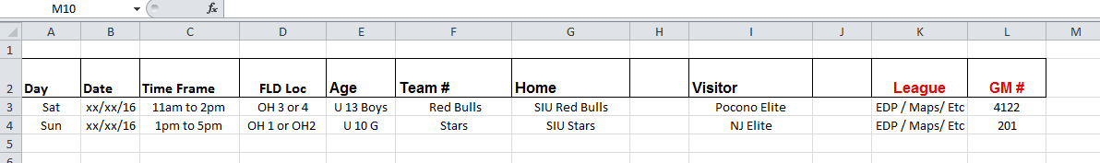

Format for Requesting a Game Change
Example
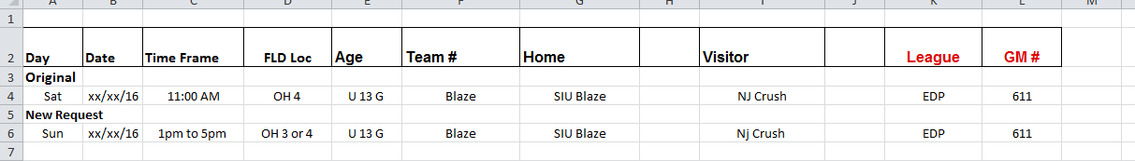
I checked the SIYSL website and OH 3 and 4 due appear open during the requested time frame
How To Check SIYSL Website for Open Fields
http://apps.tsisportsnet.com/league/statenislandfall.htm
Step 1: Click on Schedules then Game Date Field
Step 2 : Click On the specific day you are looking for
Step 3 : Click Specific Field
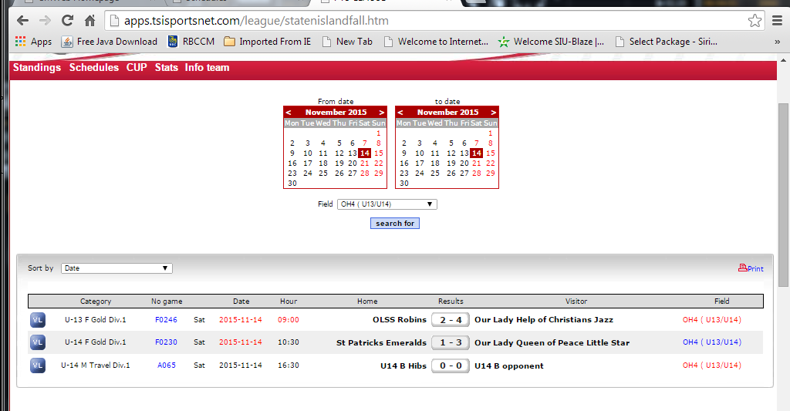

Registration US Club

Creating new players in KYCK

Log into KYCK at: https://account.kyck.com/accounts/sign_in

You first must gather birth certificates for all your players. The birth certificate must be either a PDF or a JPEG. Easiest way is for your parents to take a clear pic of the birth certificate and email it to you. Save the copy as a JPEG on your desktop. You will also need a clear face pic of every player.

- Click on the SIU Logo to access your team and select the drop down menu on “All Teams” and click on your team…
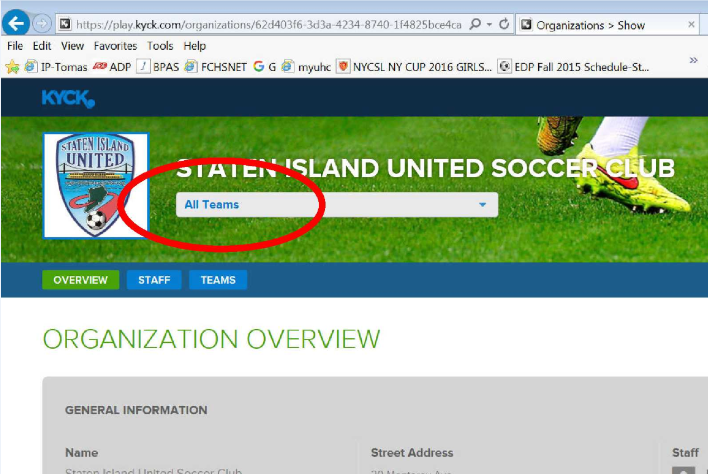

- Click on ‘Players” and select “Add New Player”…
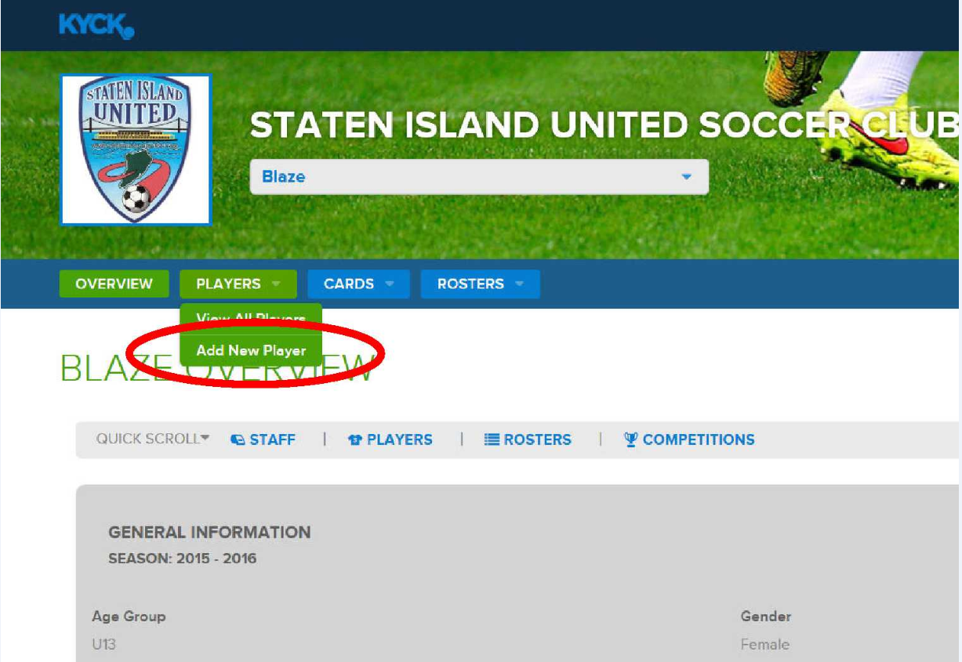

- Enter all the requested info but DO NOT FILL OUT “PLAYER’S CONTACT EMAIL ADDRESS. Leave this area BLANK!...
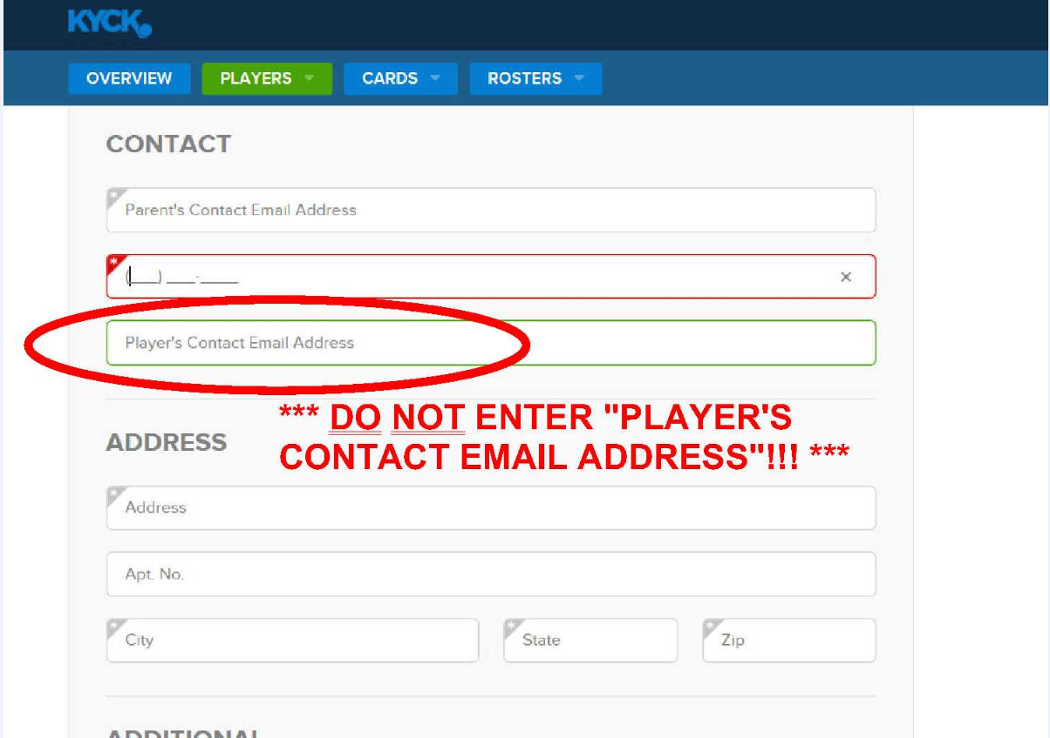

- You must upload the Birth Certificate and for the Medical Waiver just click on “Certify on File”…
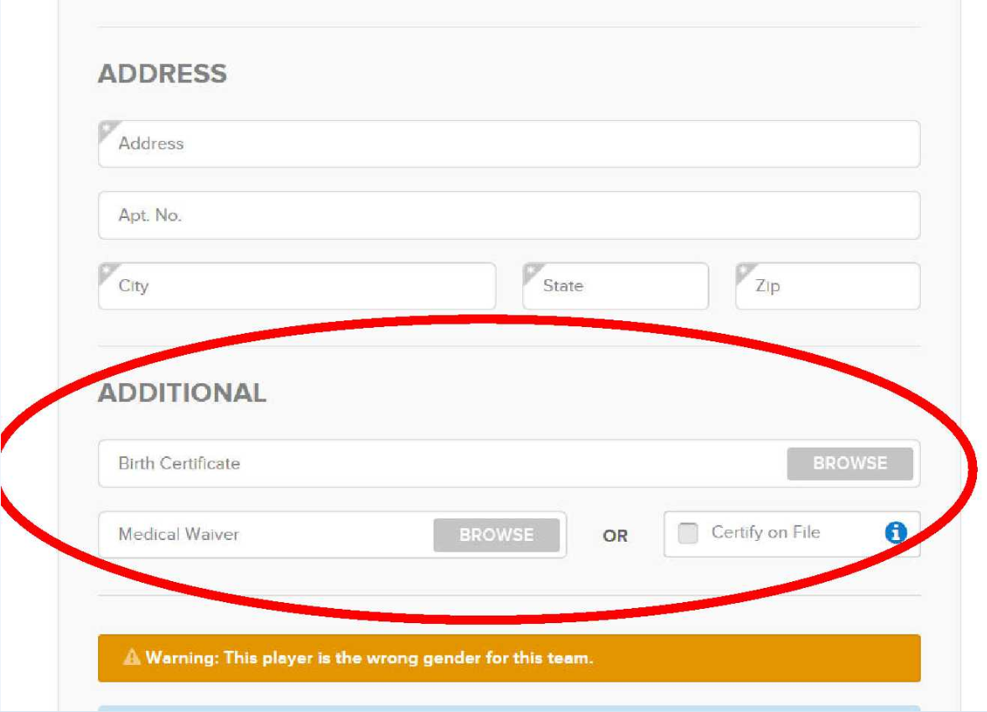

- Contact Shawn Dulligan when everything has been completed so passes can be approved by U.S. Club Soccer.

- Once the pass cards have been approved, you will login to your team’s KYCK account and select “Card” to print up the passes. Passes must be in color and must be laminated.

- You will need these passes and a copy of your approved KYCK U.S. Club Roster for every game.

- Your “Approved Roster” will have a future “Passcard Expires” date.

Basics in Using GotSoccer

Once you have received your team’s GotSoccer login credentials, you can access and login to GotSoccer at: https://www.gotsport.com/asp/users/login_menu.asp

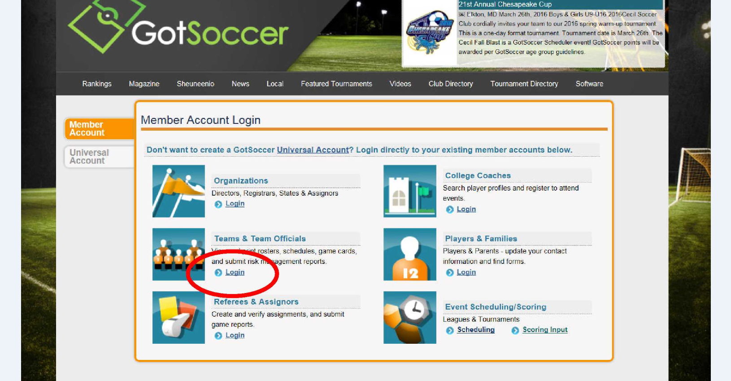

Your team’s league and tournament registration history will be listed on your GotSoccer Overview page under Event Registration History…
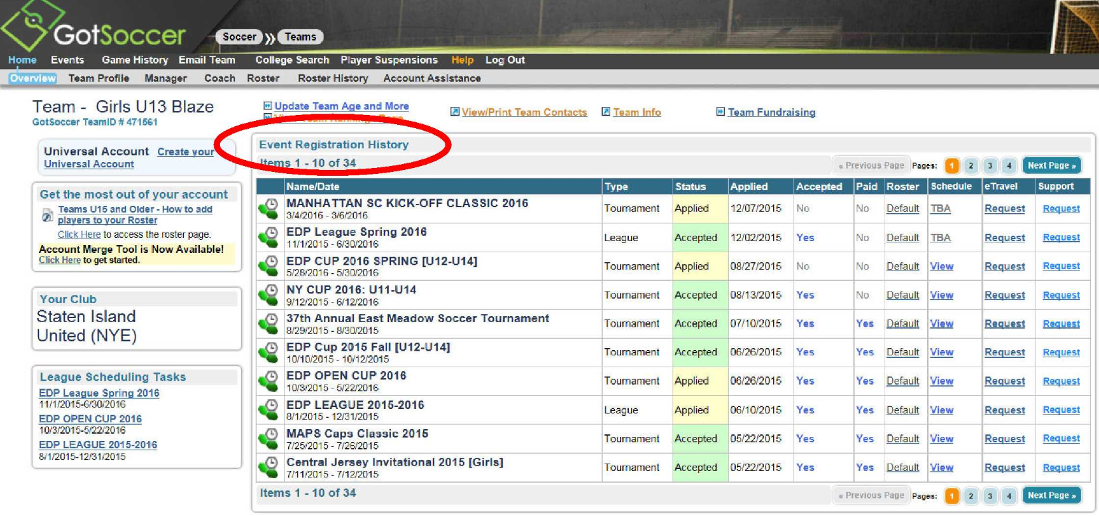

Click on your Team Profile and make sure the Basic Team Info and Contact Person information are correct. If applicable, update the Team Record section. The Team Record section will ensure your team will be placed in appropriate flights for tournaments...
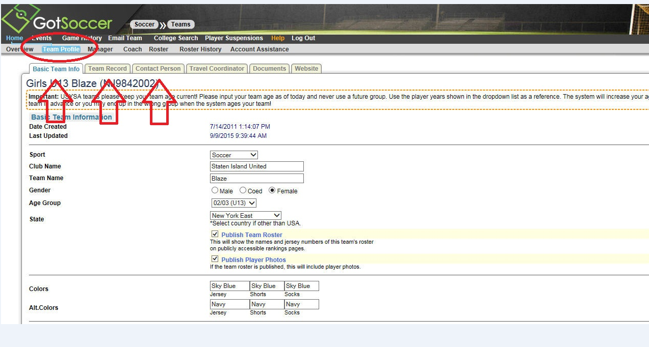

Registering a new player to GotSoccer

Before adding a new player to GotSoccer, please contact your boys/girls coordinator to make sure the new player is registered and approved on U.S. Club Soccer. If you register a new player on GotSoccer but they don’t have a U.S. Club pass, they will not be able to play. GotSoccer and U.S. Club Soccer are separate organizations and do not pull information from each other. Some leagues like EDP require an approved U.S. Club Soccer roster along with a GotSoccer Game Card for every league match.

To register a new player, click on Roster and then select Register New Player…
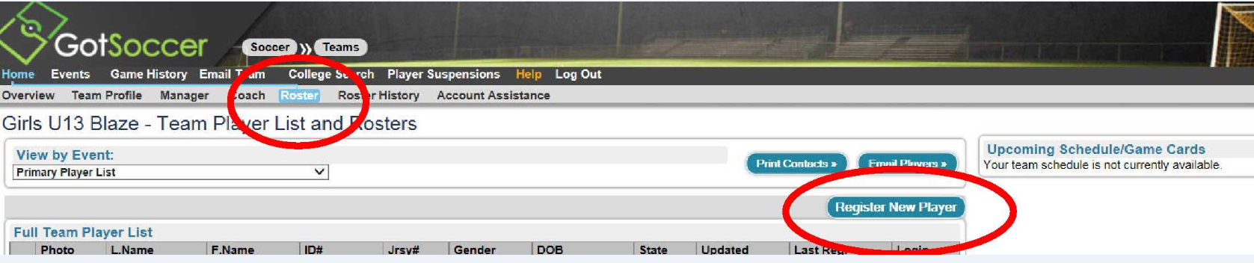

Fill out as much information on the New Player as indicated below and save…
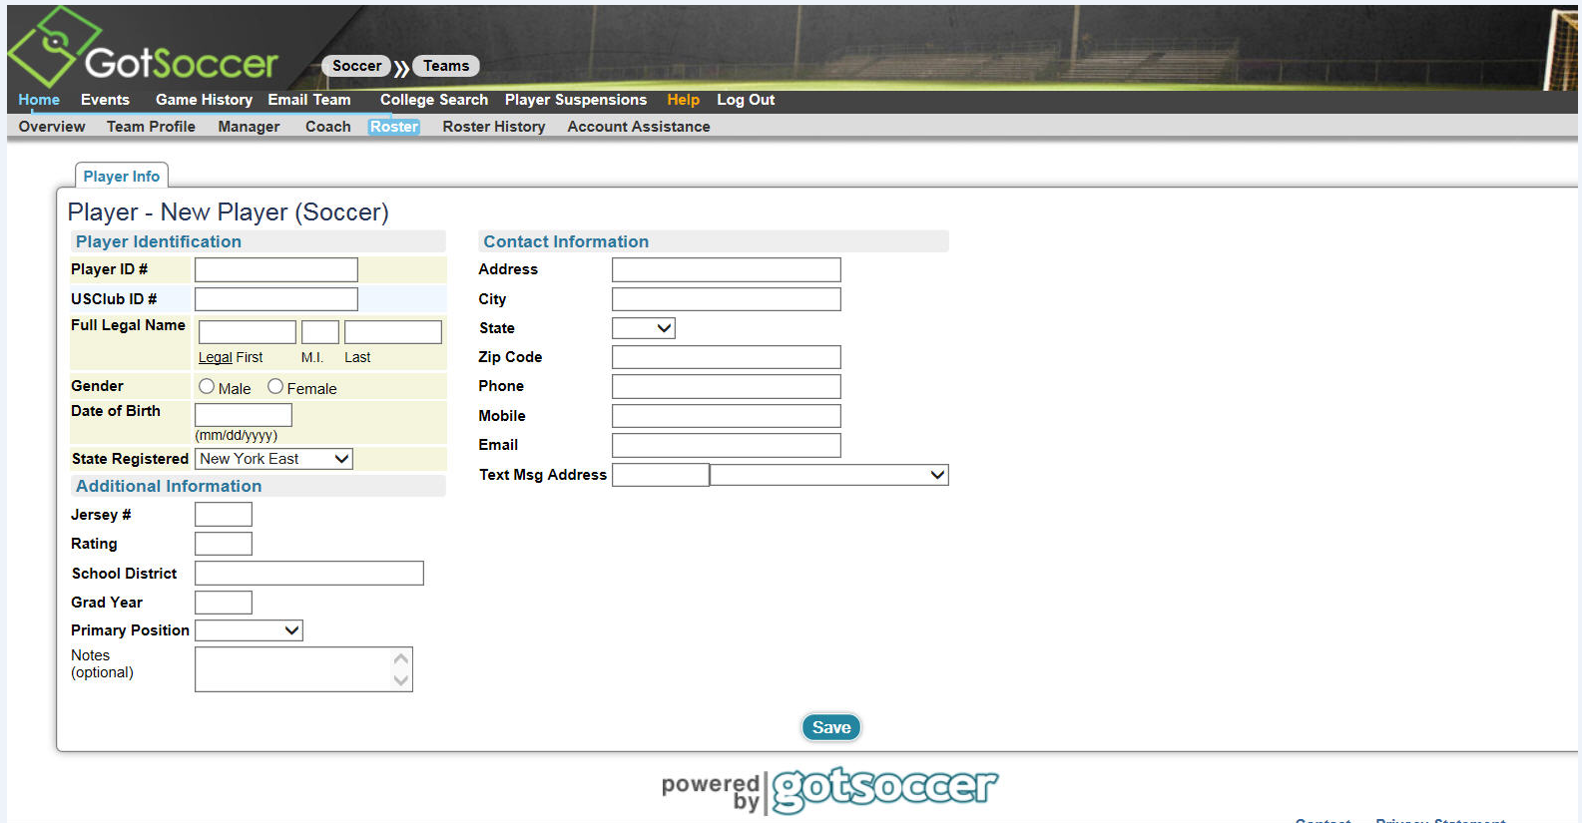

The “Help” section is very informative and will help you navigate GotSoccer. It may also answer a lot of your questions regarding rankings, points, etc…
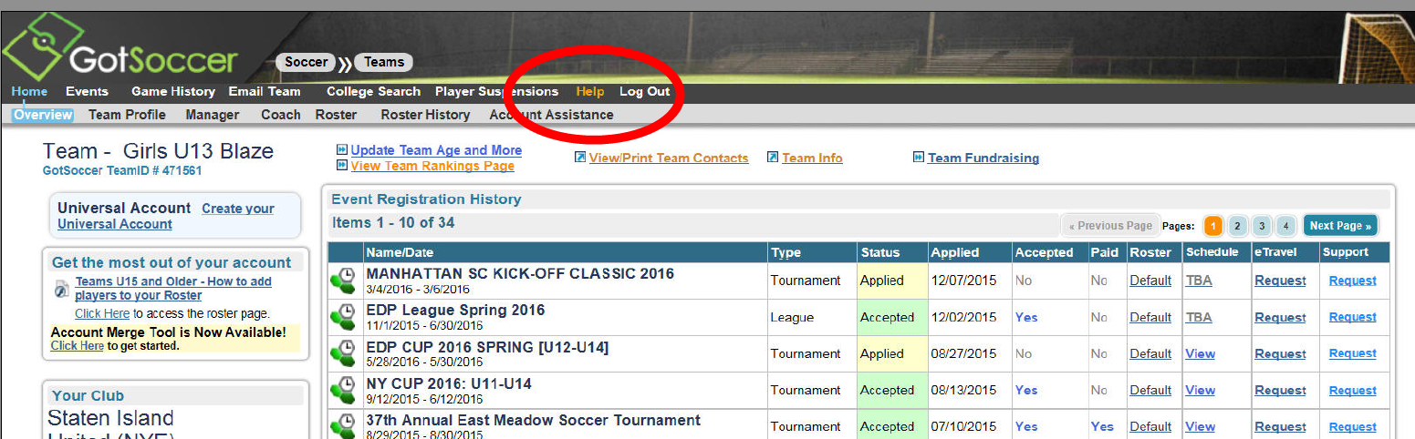

BUDGET PAGE
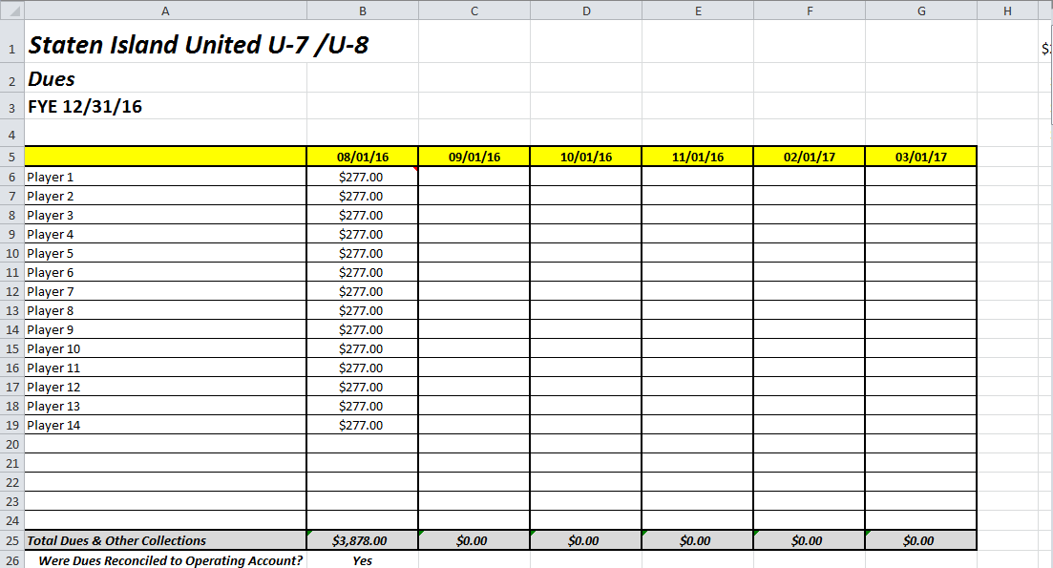

To open a working Excel file please click here

Game day page
REF FEES
It is the manager’s responsibility to have the exact referee fees for every game. For EDP/Maps games, the referee fees are split evenly between teams. The home team is responsible for paying the ref fees for MOSA games. Know the rules for your league.
Passes & Roster
Player and coaching passes are required for every game. These passes must be in color and laminated. For EDP games, a GotSoccer game card along with an approved U.S. Club Roster is needed for every game. For NY Cup games through NYCSL, just a NYCSL approved U.S. Club roster is needed. Know the rules for your league.
League Rules & Regulations
The manager should be acquainted with the rules and regulations of their league and have a copy of the rules handy at every game.

Communication Page
Create mail address for team
The manager should be organized and have everyone’s contact information such as: Home address, email address, cell numbers and home numbers. Easiest way to get in contact with everyone is a group text blast or a group email.

Email / text distro list / team apps
Third party free apps such a “Team Snap” or “SportUp” can be very helpful in keeping your team informed and engaged. It is highly recommended that you use these apps. This is a very easy way to connect and communicate with your team. These apps are very to use. Many of the United teams are already using these apps and can help you get set up.
Creating a rolodex of teams for scrimmages
It is advisable for Manager’s to keep an organized contact list of your opponents. Mangers should maintain cordial relationships with every team. This will help you with rescheduling league games and/or setting up friendlies. You never know when you need a favor from another team.
Winter Schedule Page
How to go about getting a School gym for winter
During the winter, most teams practice indoors in a public school gym. You can call the school directly and ask to speak to the person in charge of permits. Some schools require teams to pay for a school safety officer to be present during practices. The cost of a school safety officer is expensive. You can ask the school to waive the school safety officer fee if you have a parent or a relative on the team who has a law enforcement background. You will have to provide details to the school on your team’s security plan involving this particular law enforcement official.
There are a few rules about using public school gyms. Violation of these rules can have your gym permit rescinded.
- Only water is allowed in public school gyms. Sports drinks are strictly prohibited.
- Make sure your players respect school property
- All trash and bottles must be picked up after every practice. The gym should be clean upon leaving.
- Most gym permits allow a certain number of occupants in the gym. This is an insurance liability issue. Parents and siblings are highly encourages not to be in the gym during training. The presence of parents can be a distraction. Some coaches enforce this rule.

How to apply for insurance for winter gyms
John …please provide instructions on obtaining insurance policy NYC public schools require a minimum $4 million in liability.

Winter league vs winter tournaments
Popular winter leagues are The Fields in East Brunswick, NJ, Tab Ramos in Aberdeen NJ, Center Circle in Rahway, NJ & Futsal at Rutgers University.
Common one-day tournament venues are Soccer Coliseum in Teaneck, NJ, The Fields in East Brunswick, Rockland Community College, Soccer Palace, etc. There are also 1-day tournament on Long Island and north of NYC.
One-day winter tournaments require less traveling and you get to play multiple games on the same day. Players also get to rest in between tournaments. This is particularly helpful if your team had a congested fall schedule.
Winter leagues require traveling every weekend to play. The leagues are usually around 8 or 10 weeks. Scheduling conflicts may arise if players on your team play other sports during the winter, especially basketball. The benefit of playing in a league is playing every weekend. You can easily measure improvements and development of players this way.
Keep in mind, most of these tournaments and leagues are small-sided. If you’re playing in a league and have a large roster, you may have to bring a certain numbers of players every week in order to maximize playing time and reduce travelling for families.
Tournaments
Applying to Tournaments
The Club will recommend tournaments for each team to attend. Do not apply to any tournament until you receive an approval from your group coordinator. If you plan to attend additional approved tournaments outside of the recommended events, please read and understand the tournament’s rules before applying. Go directly to the tournament’s main website or apply through GotSoccer. Most tournaments have links that will re-direct you to GotSoccer to complete registration. It is very important to make sure your team’s GotSoccer team history is up-to-date so your team can be properly flighted.

Team Check-in/Registration requirements
Each tournament has their policy concerning team check-in. Follow the check-in directions extremely carefully.
You will need:
- Original Player Passes
- Approved U.S. Club Roster
- Medical Releases
- There will be special instructions for Guest Players

Organizing hotel accommodations for away tournaments
Tournaments which are not commutable will require overnight hotel accommodations. Some tournaments require teams to go through the tournament’s official lodging company for hotel rooms. Teams that are staying overnight at these tournaments are required to book rooms through the official lodging company. Failure to comply with this requirement may lead to revocation of a team's acceptance in the tournament.

